**Task2- Student Database Management System(PostgreSQL)**

3. Student Information Retrieval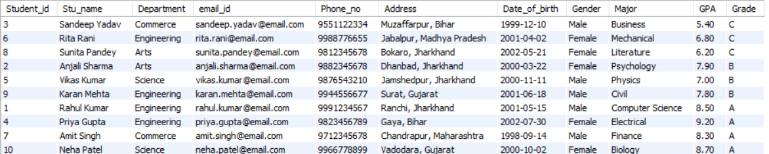

4. Query for Male Students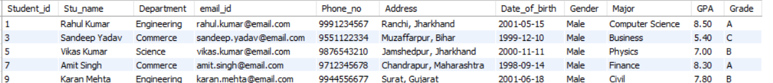

5. Query for Students with GPA less than 5.0

6. Update Student Email and Grade

7. Query for Students with Grade "B"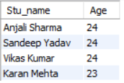

8. Grouping and Calculation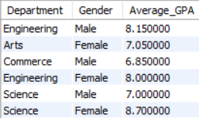

9. Table Renaming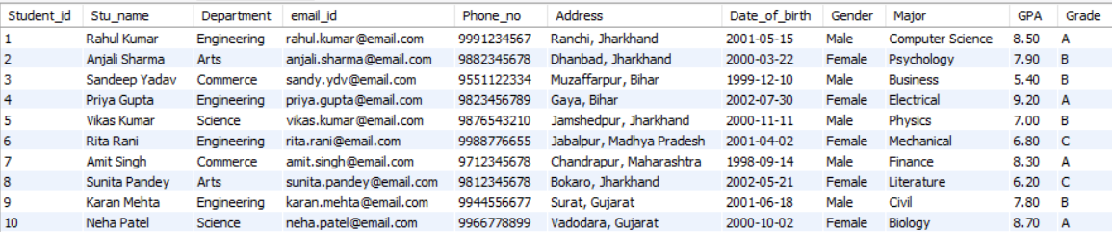10. Retrieve Student with Highest GPA